**LAB AUTOMATION / PRODUCT TESTING  
MANAGEMENT SYSTEM  
  
DEVELOPER GUIDE**

Goup Members:

|  |  |  |
| --- | --- | --- |
| |  | | --- | | Student1613939 | | MARYAM |
| Student1644851 | OKASHA BUKHARI |
| Student1645249 | MUHAMMAD HASHIM FARAZ |
| Student1649373 | MUHAMMAD ABID |

Curriculum: ACCP AI

Semester: DISM

Faculty: Sir Tasbeel Jawed

## **Certificate of Recognition**

This certificate is proudly presented to the development team of the  
**Lab Automation / Product Testing Management System**  
in recognition of their outstanding effort, dedication, and innovative approach in automating laboratory testing and product management processes.

The successful development of this system demonstrates excellence in system design, functionality, and teamwork. By digitizing the product testing workflow, the project contributes significantly to improving accuracy, efficiency, and traceability in industrial product testing.

This recognition stands as a testament to the hard work, commitment, and technical skills of the project team and highlights their role in advancing automation and digital transformation in laboratory environments.

**Presented On:** ____________________  
**Authorized By:** ____________________

## Acknowledgement

We would like to express our sincere gratitude to all those who contributed to the successful completion of the **Lab Automation / Product Testing Management System**.

First and foremost, we extend our heartfelt thanks to our respected instructor for continuous guidance, valuable feedback, and encouragement throughout the project development. His support and expertise played a crucial role in shaping the system according to real-world requirements and academic standards.

We are also thankful to our faculty members for providing us with the technical knowledge, resources, and learning environment necessary to complete this project effectively.

A special note of appreciation goes to our team members for their cooperation, dedication, and collaborative efforts. Their commitment and problem-solving skills were instrumental in the successful design and implementation of this system.

Finally, we would like to thank our families and friends for their constant support, motivation, and patience throughout this journey.

## Synopsis

The **Lab Automation / Product Testing Management System** is a web-based application designed to automate and digitize the product testing and record-keeping process in an industrial laboratory environment.

In the existing manual system, product testing records are maintained on paper, which leads to errors, inefficiency, data loss, and difficulty in tracking products that undergo multiple testing stages. The proposed system addresses these issues by providing a centralized digital platform for managing product details, testing records, results, and reports.

The system assigns a unique **10-digit Product ID** for each manufactured product and a **12-digit Test ID** for every testing process, ensuring accurate tracking and traceability. It supports role-based access for Admin, Tester, and Supervisor users, enabling secure data entry, monitoring, and decision-making.

Key features of the system include product registration, testing management, advanced search, result evaluation, report generation, and audit logging. Products that pass testing are forwarded for **CPRI approval**, while failed products are sent for **re-manufacturing and re-testing**.

This project enhances operational efficiency, reduces human errors, supports informed decision-making, and demonstrates the practical application of software engineering principles in industrial automation.

**Problem Statement:**

Problem Statement

1. Manual record-keeping is slow and prone to mistakes.

2. Each product may undergo multiple testing types in different departments.

3. Misplacement of records or products is common.

4. Difficulty in generating status reports for decision-making.

5. Tracking which products need re-manufacturing or CPRI testing is cumbersome.

**Requirement Specification:**

1. Product Registration:

Enter product details (name, type, batch, revision).

Auto-generate 10-digit Product ID.

2. Testing Entry:

Enter test type and test results.

Add detailed remarks and tester names.

Auto-generate 12-digit Test ID.

Update status: Pending, Passed, Failed.

3. Advanced Search:

Search by Product ID, Test ID, test type, or status.

Filter based on date, product type, or batch number.

4. Status Tracking:

View which products are in testing, re-manufacturing, or approved by CPRI.

5. Reporting:

Generate reports of products tested, failed, passed, or pending.

Maintain logs for auditing.

**Images:**

Navbar

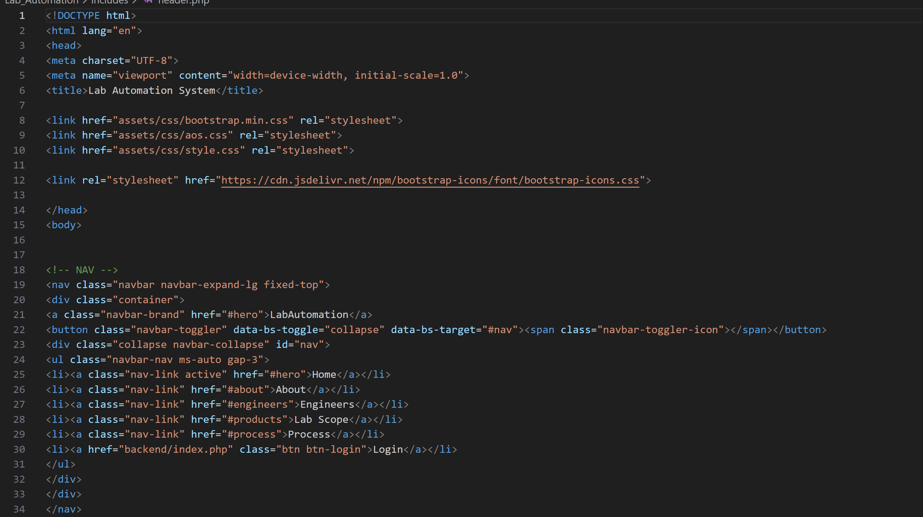

Footer

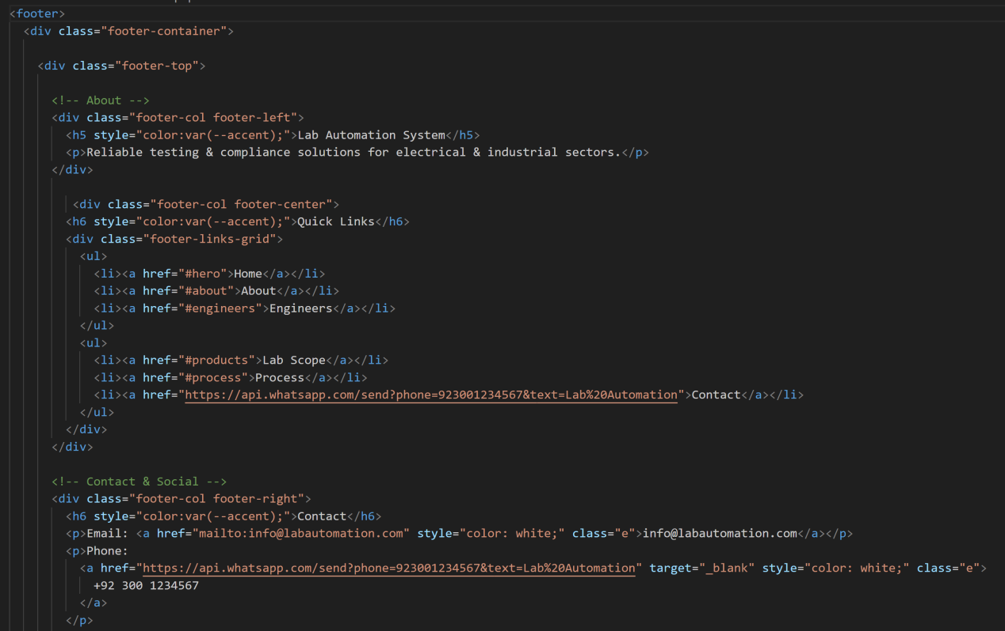

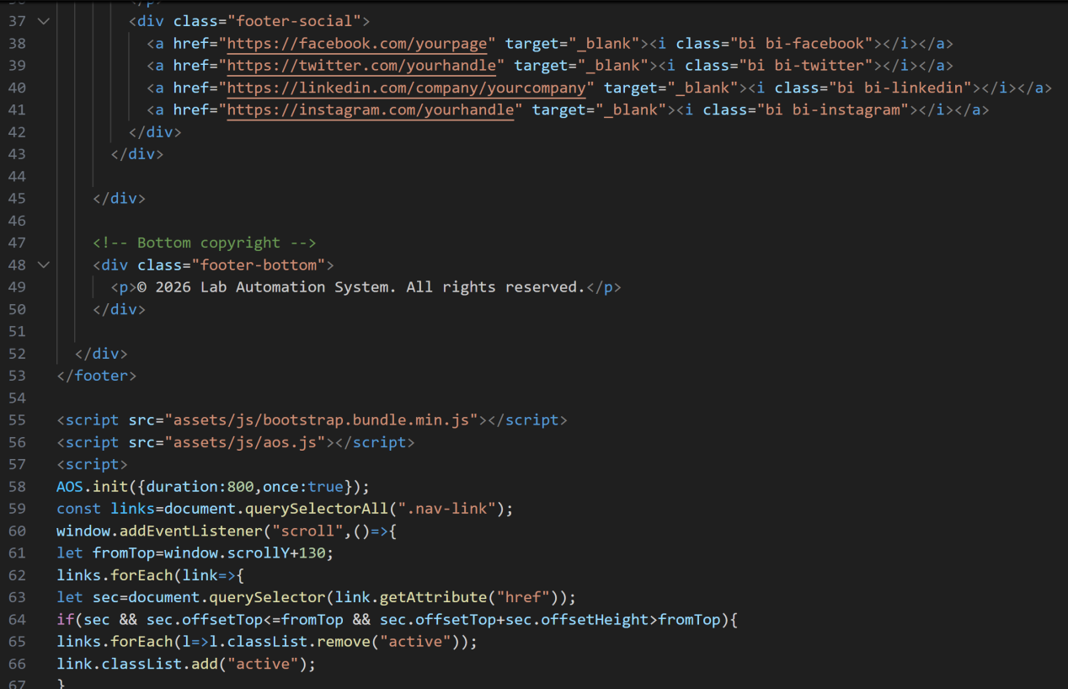

Login Page

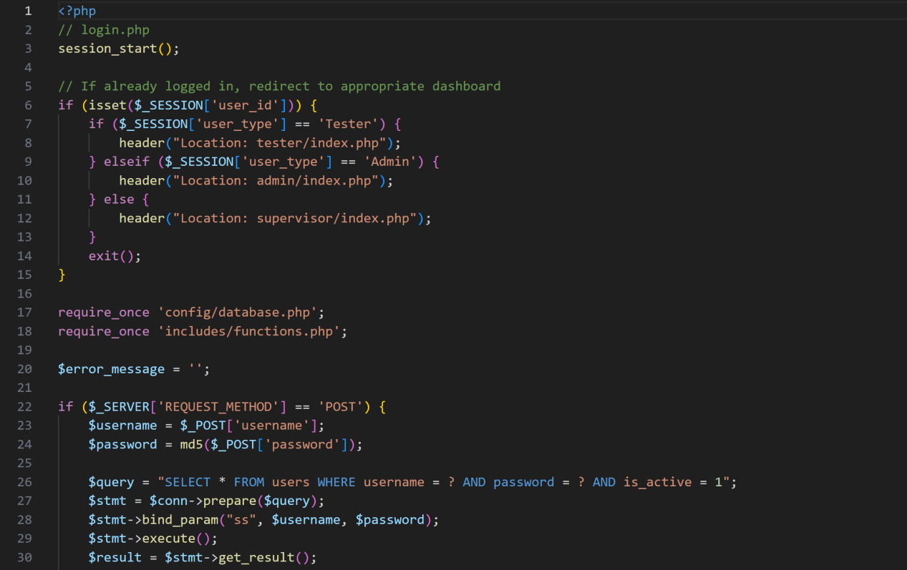

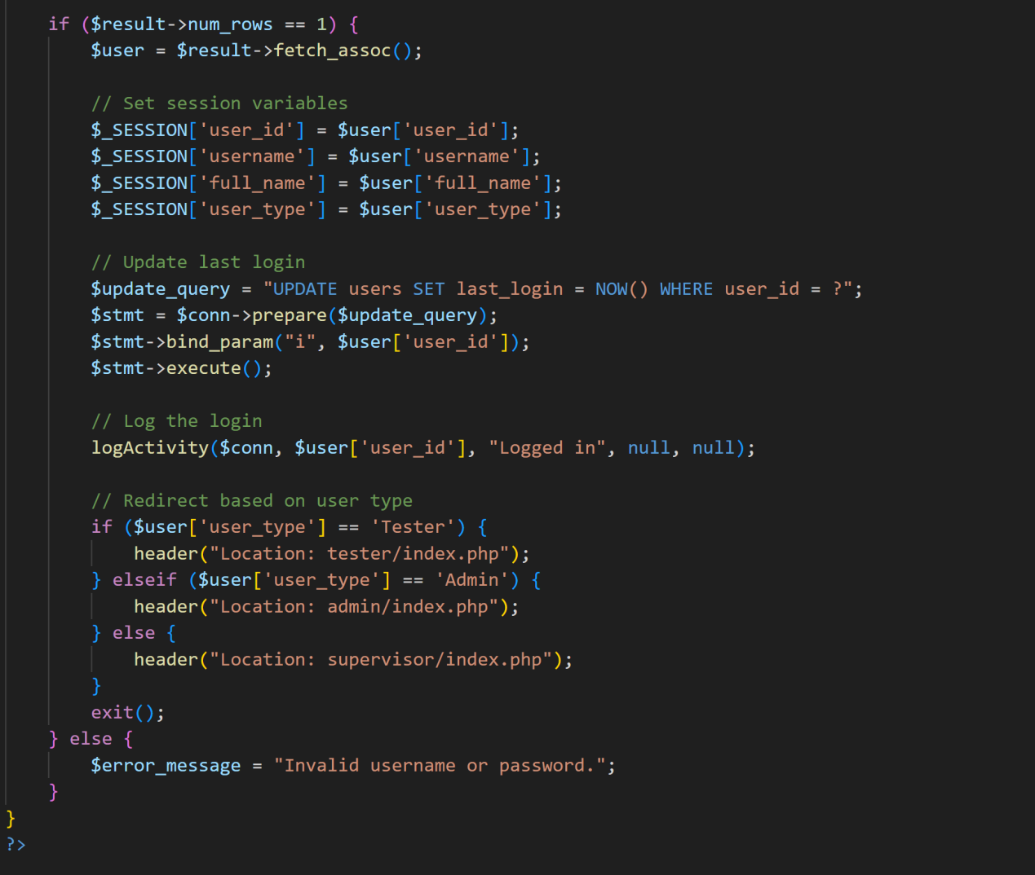



Logout Page

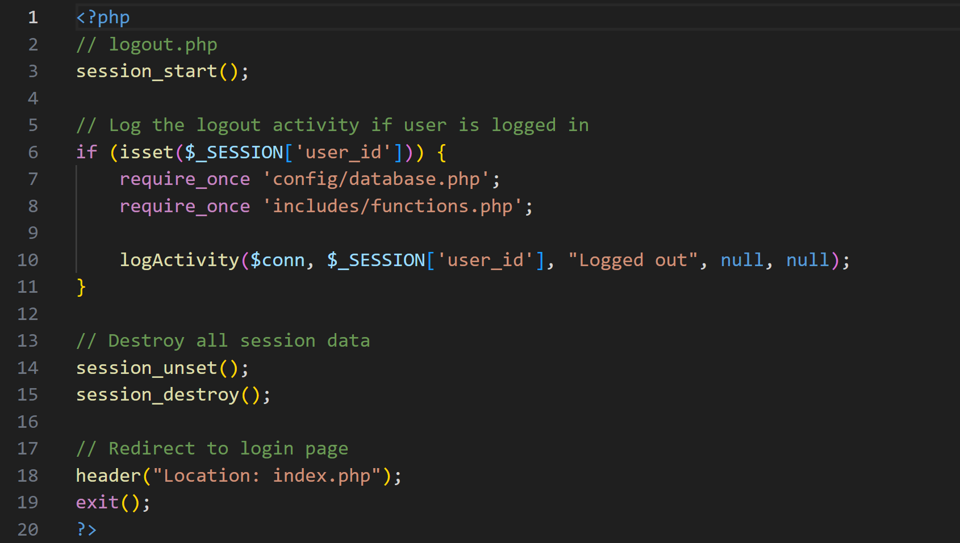

Admin Product Pages

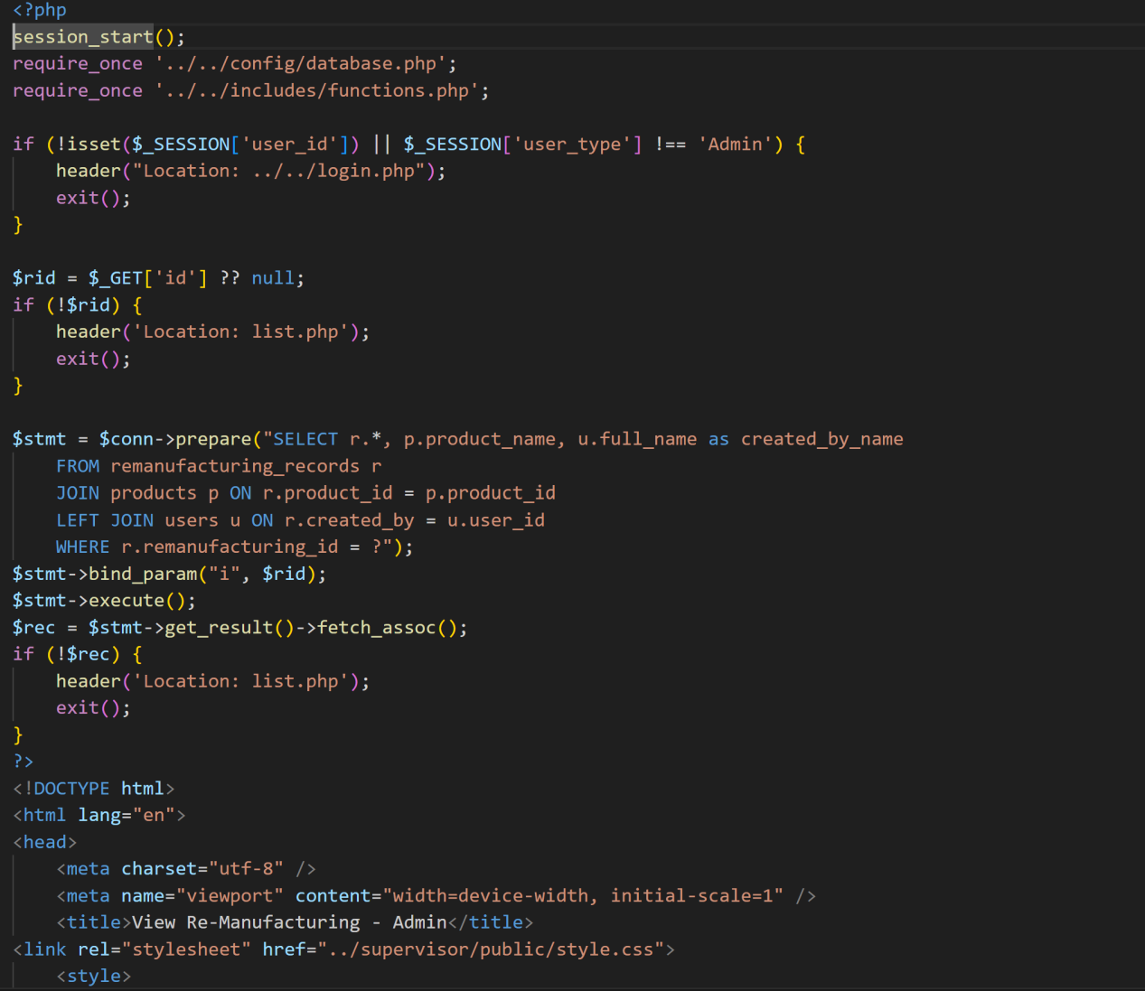

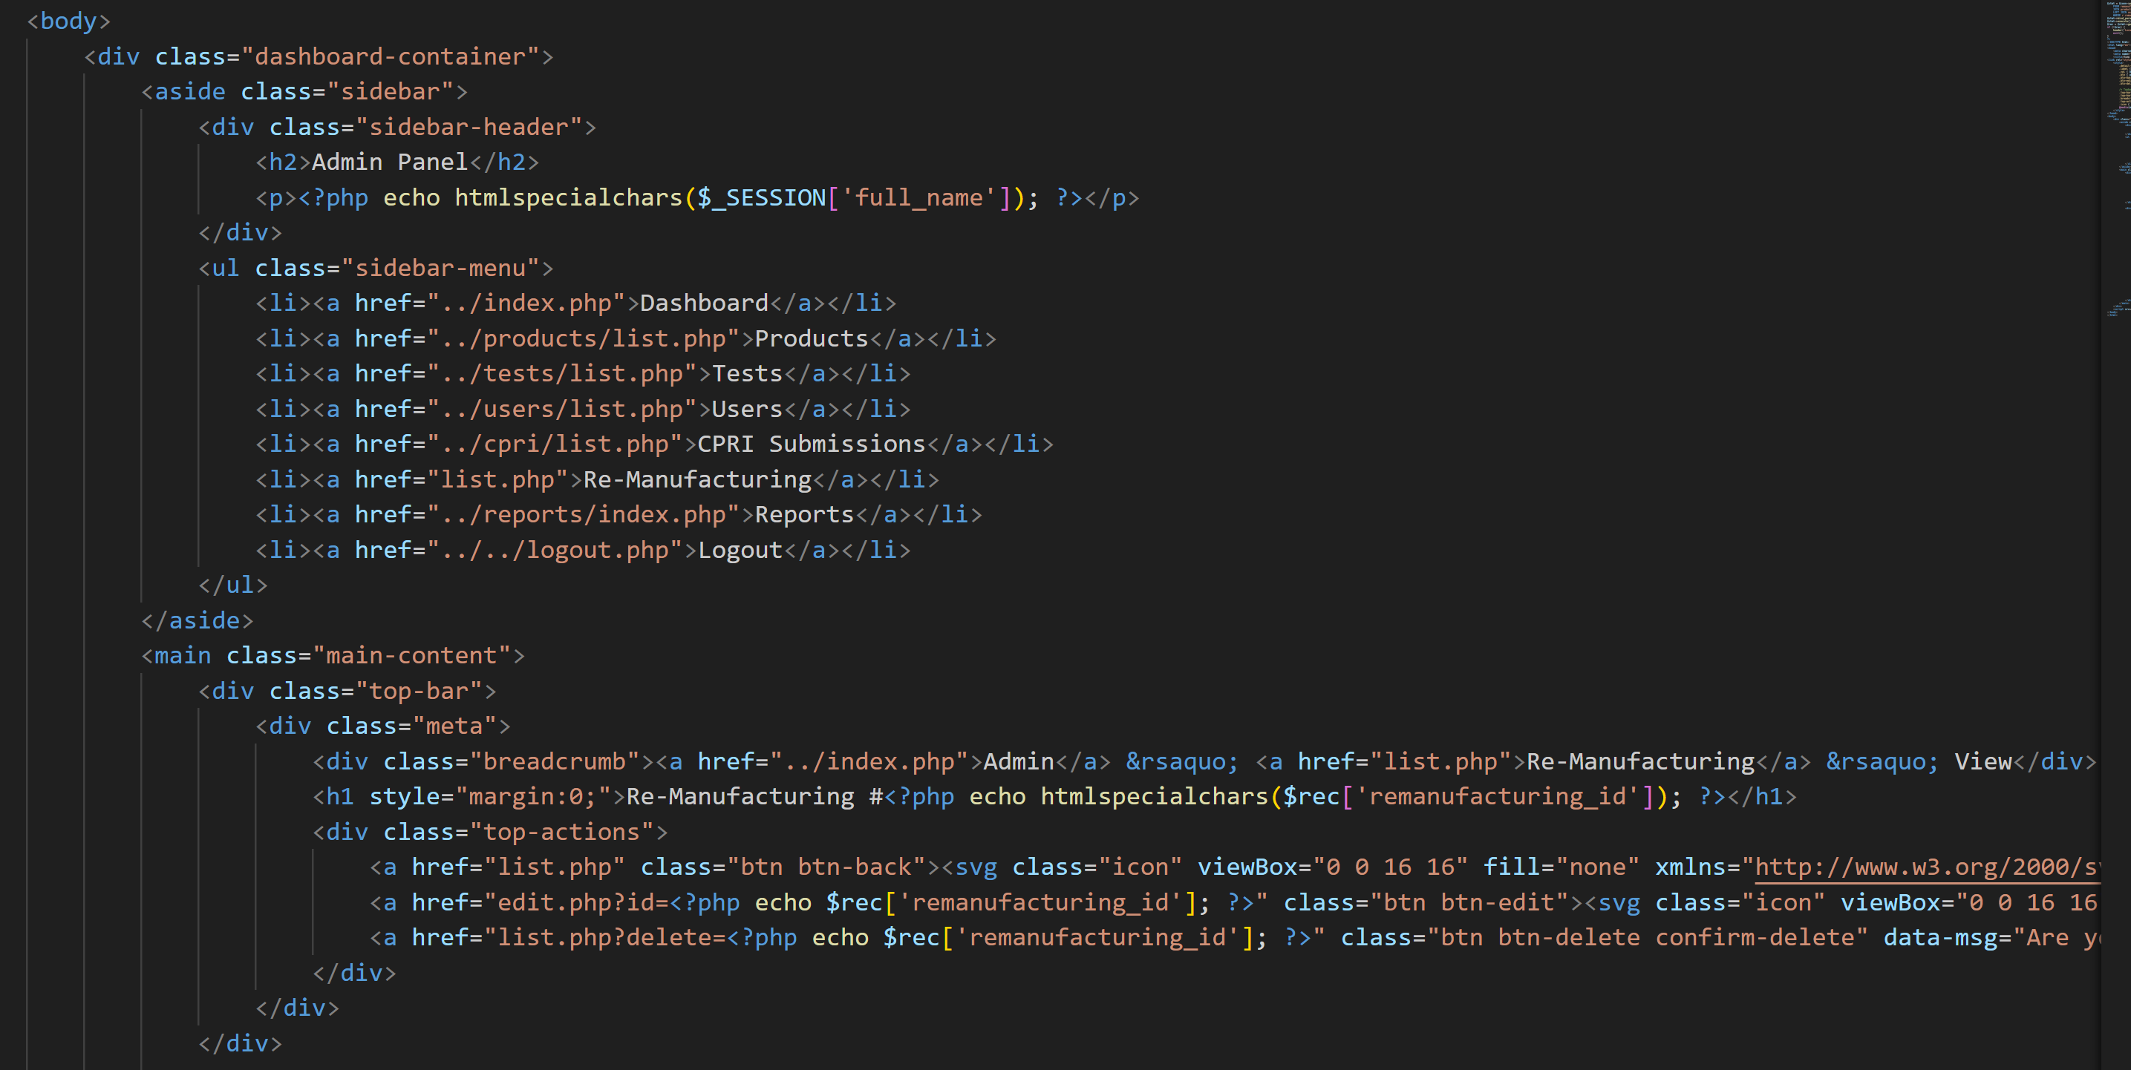

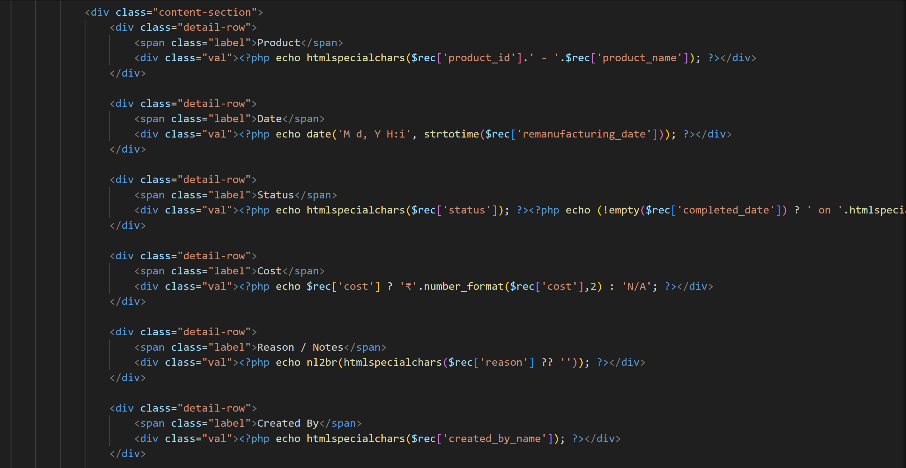



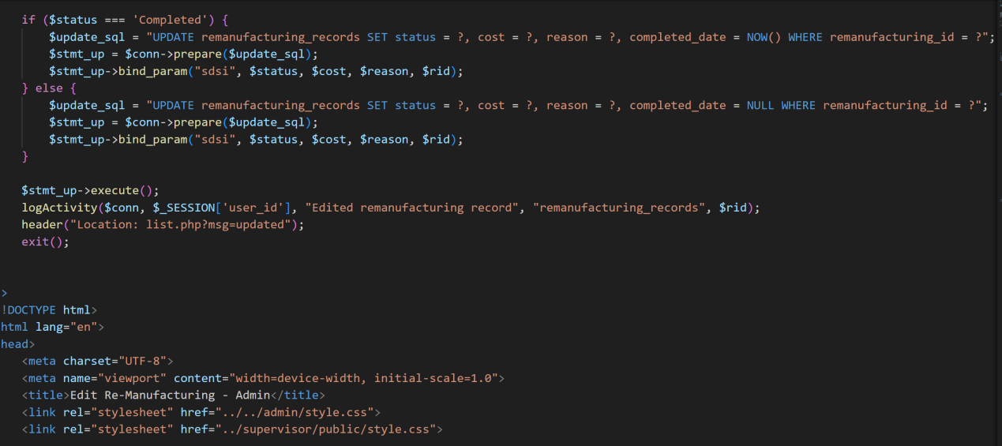

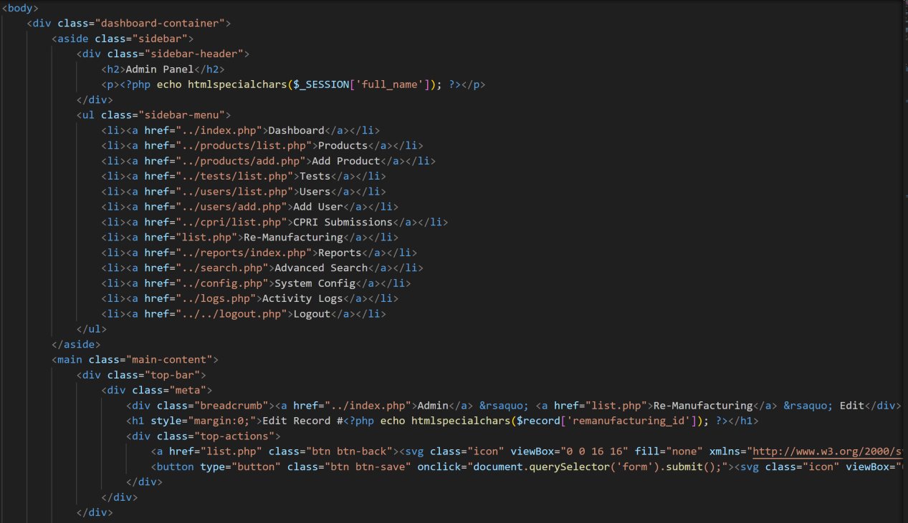

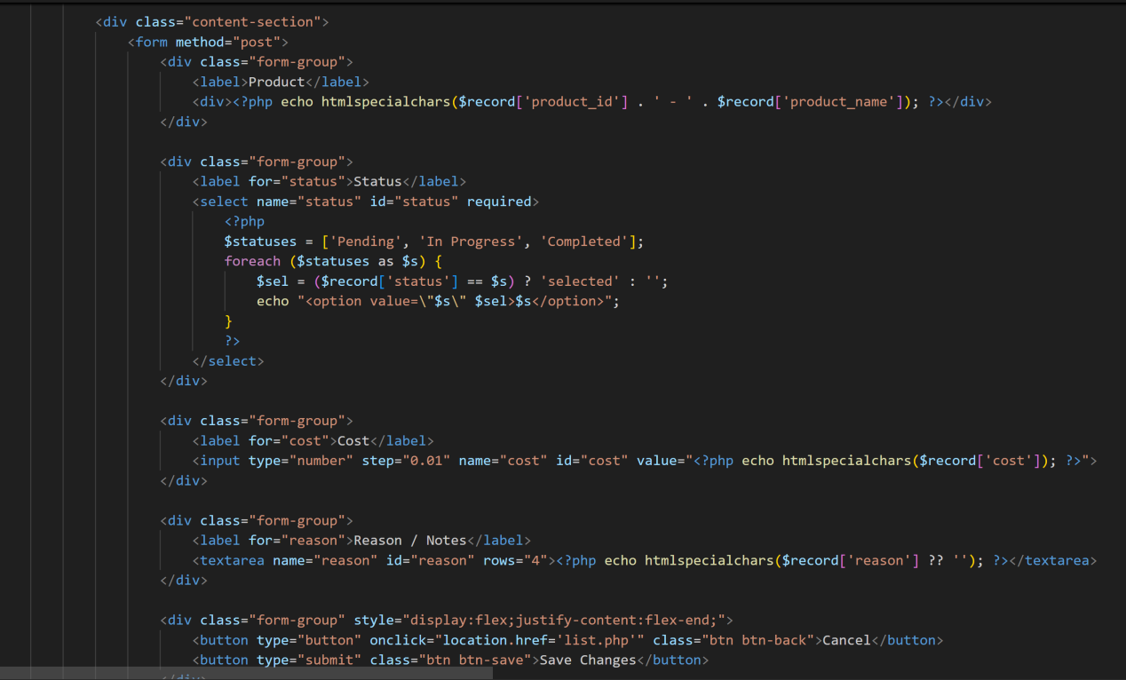

Supervisor Update Product/Test Pages

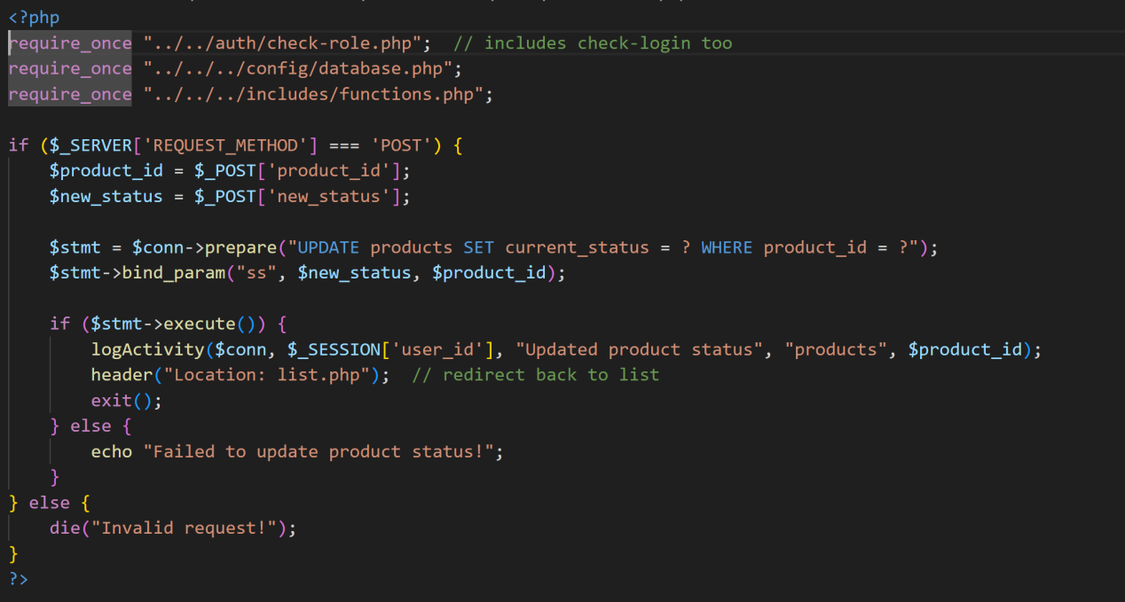

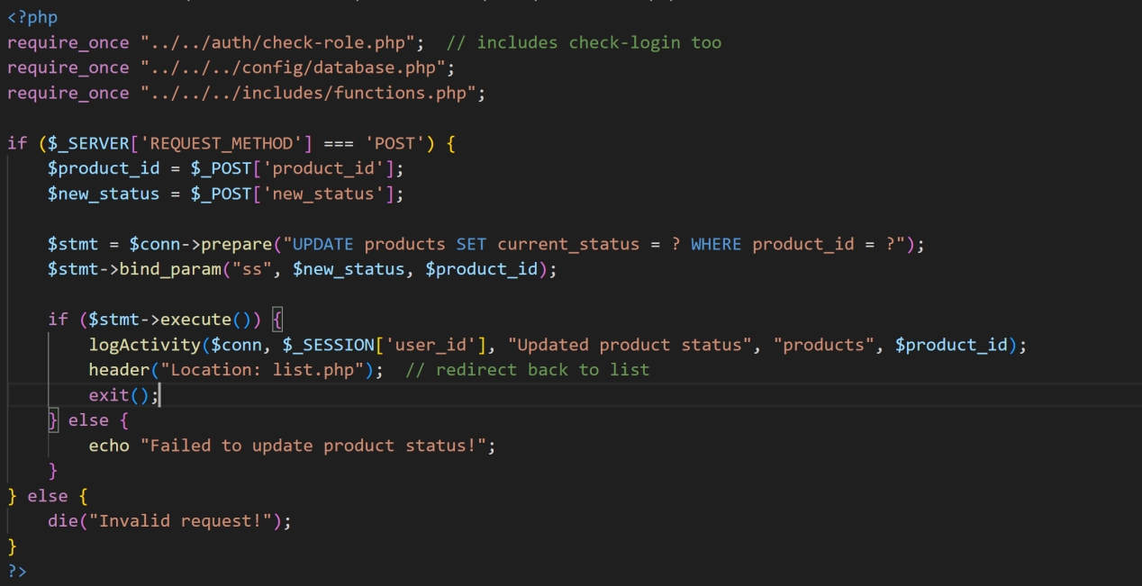

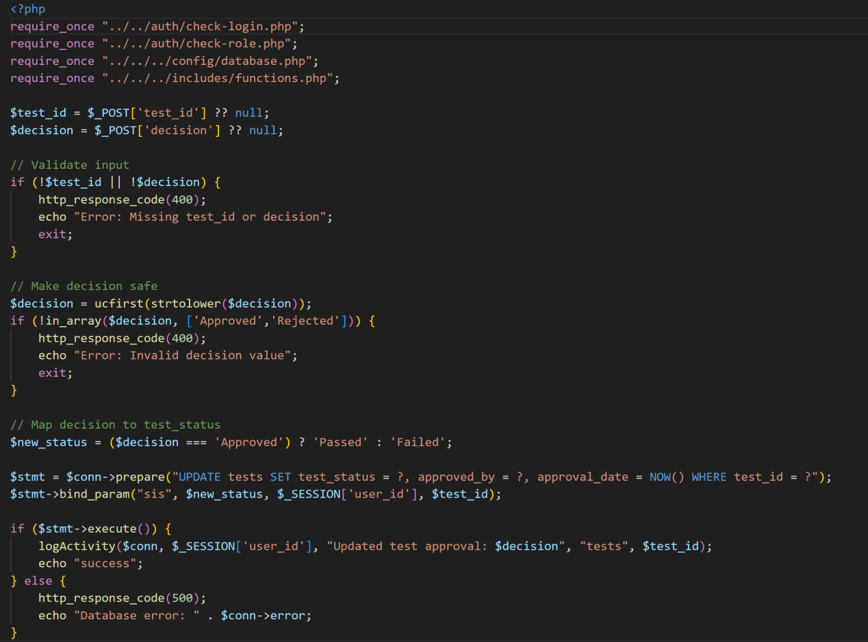

Tester Testing Pages

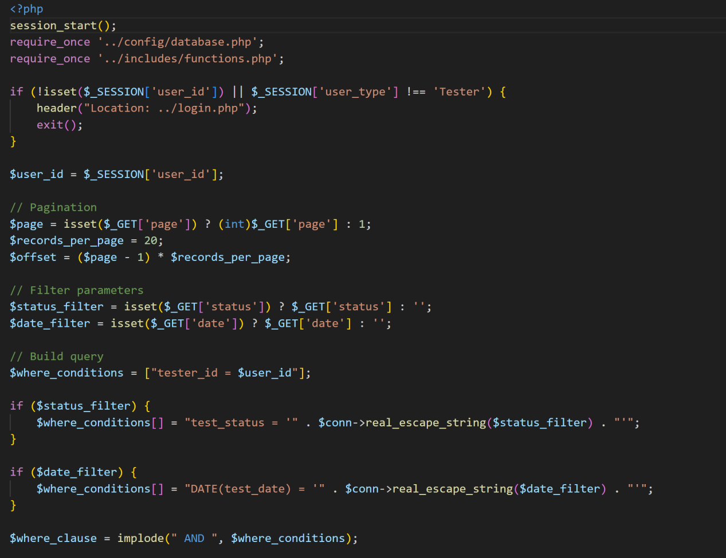

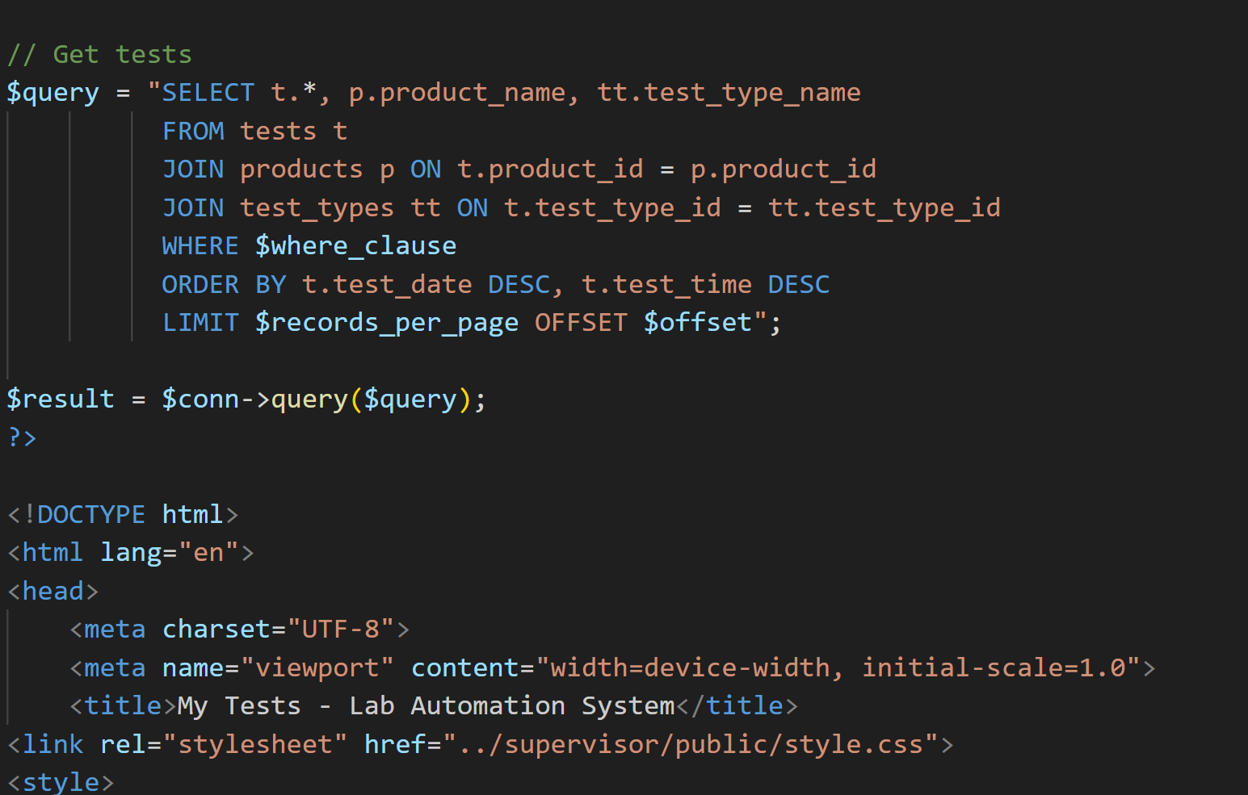

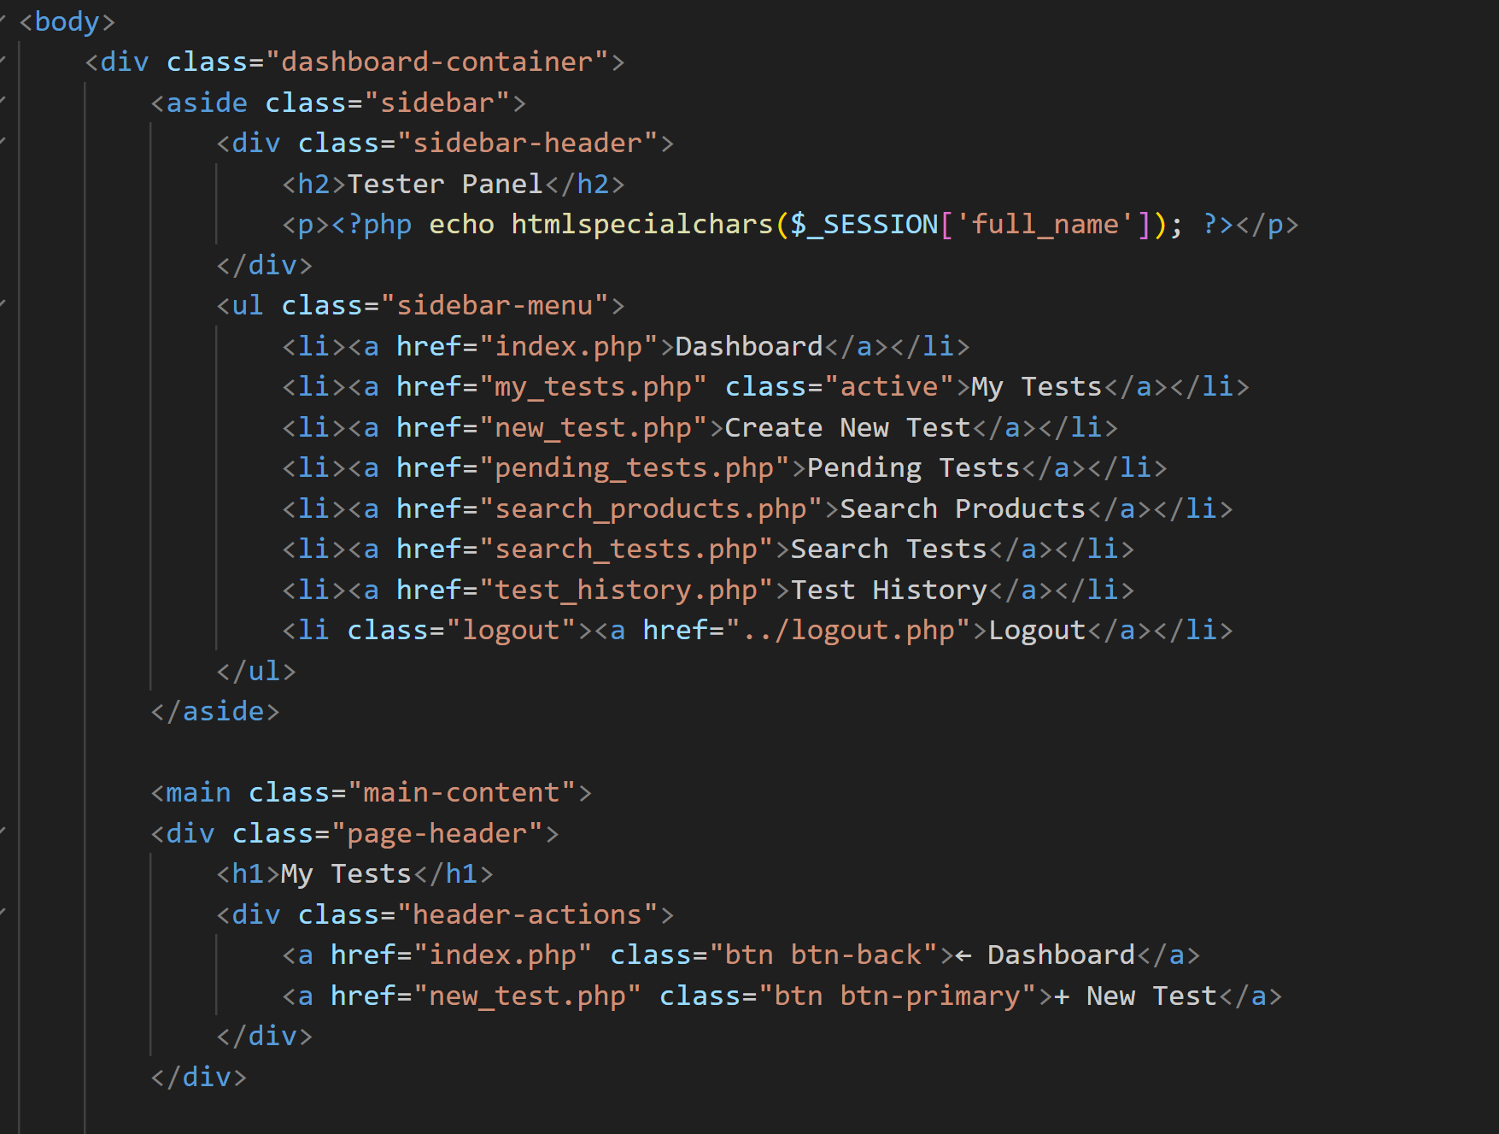

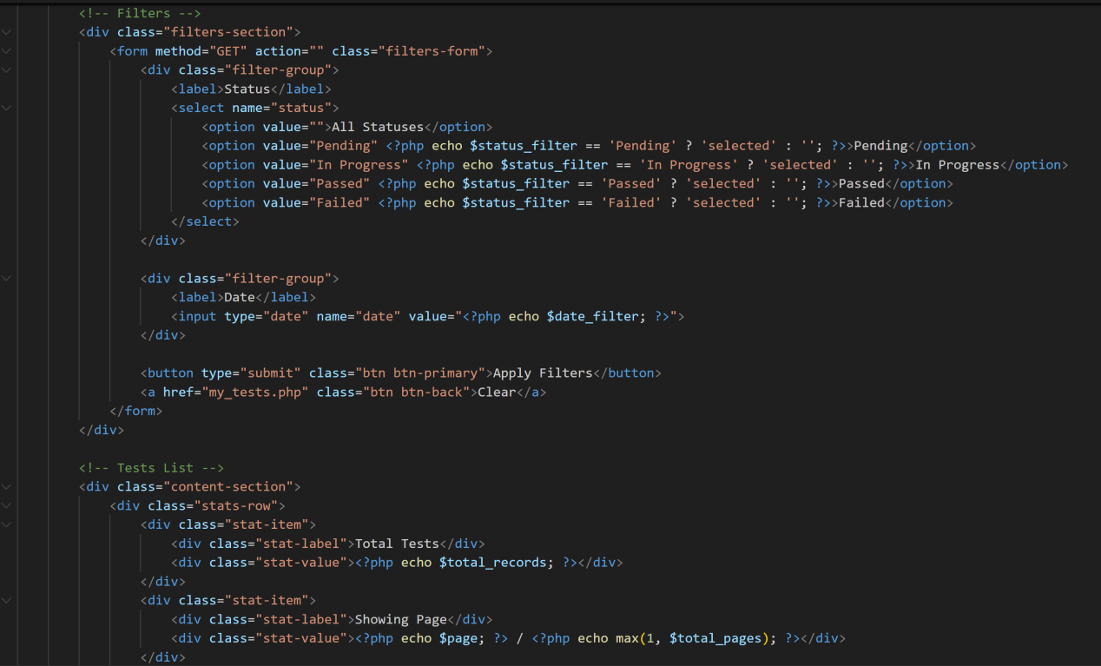

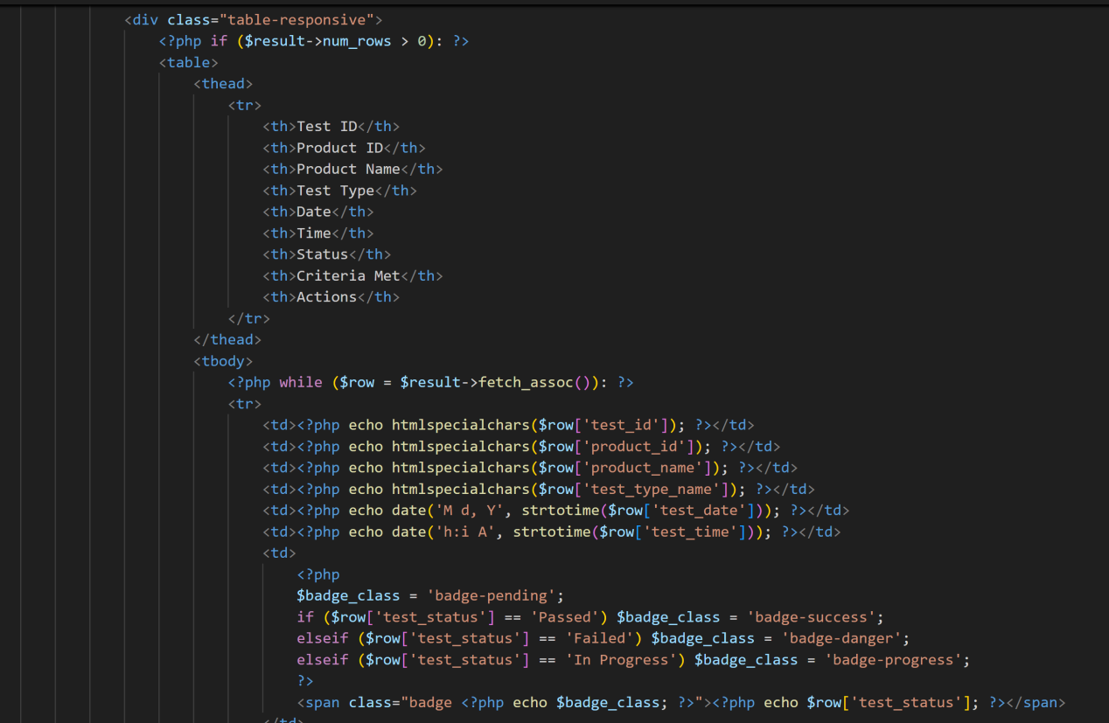

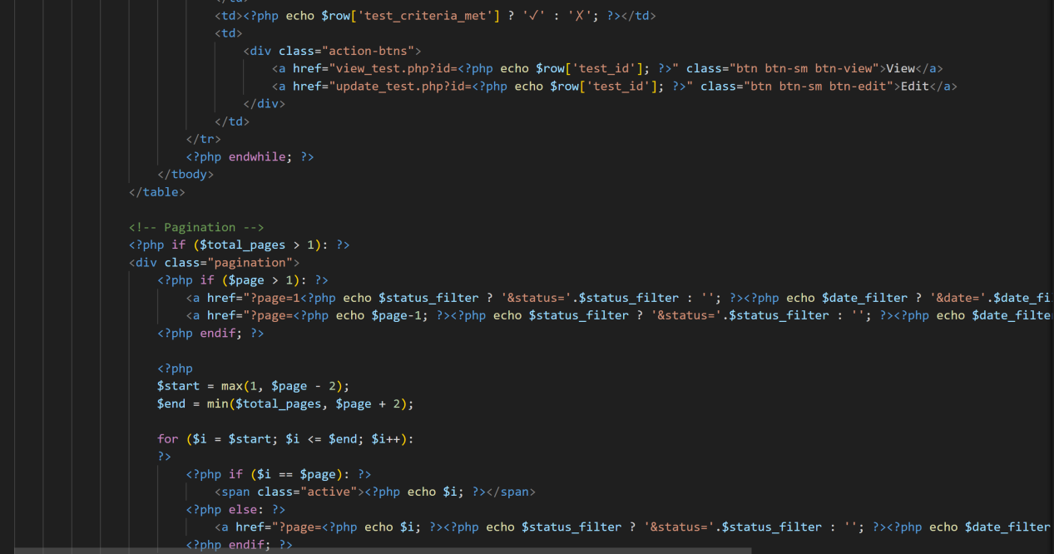

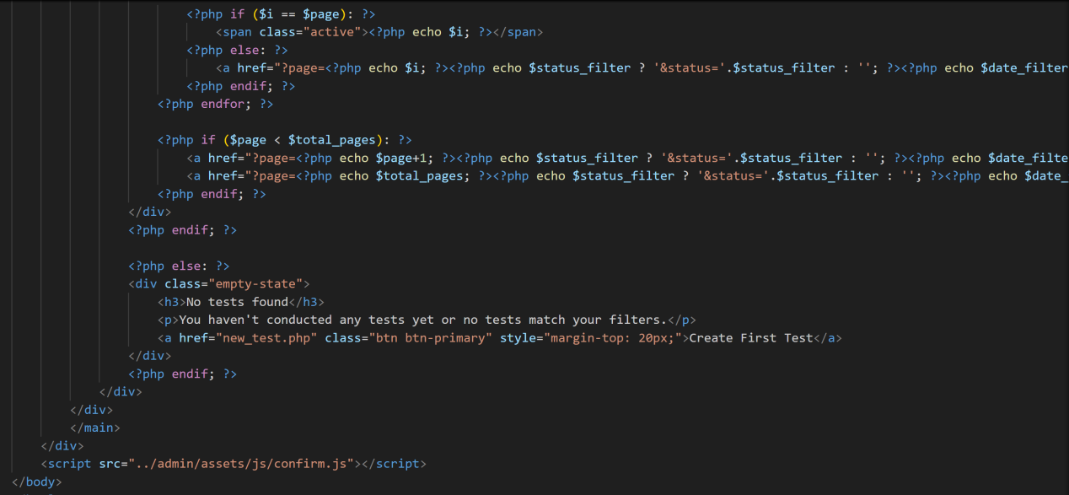

Database Page

